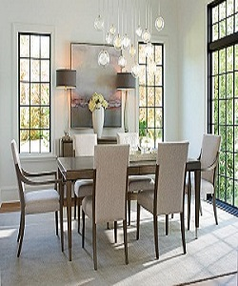

Dining table

$150.32

Availability: In stock

Description

The Lexington Furniture Collection Dining table is uniquely designed to impress and be added to your room it features wood rectangular shaped table and tapered legs Made of high quality materials it most rates delicate craftsmanship.